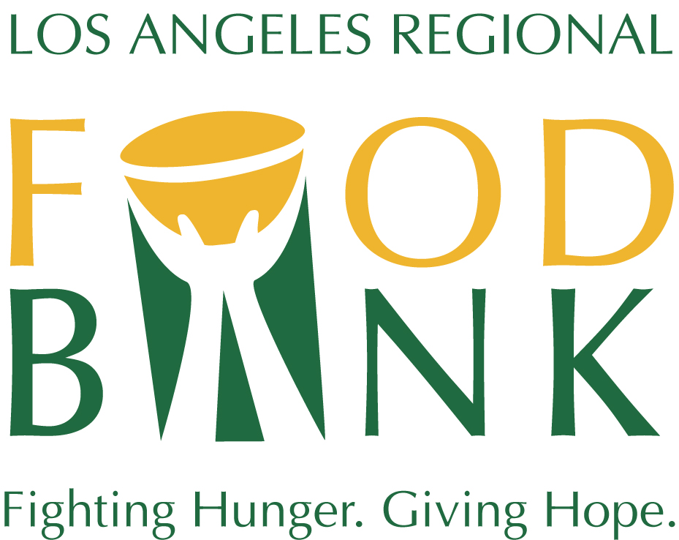
Food From The Bar

The Food From The Bar (FFTB) Campaign is an annual effort led by the legal community, focused on providing nutritious meals for children in Los Angeles County. The organizations that launched this effort – Los Angeles Regional Food Bank, Los Angeles County Bar Association, Women Lawyers Association of Los Angeles and the Food From The Bar Steering Committee – invite you to join attorneys, staff and their families in supporting this important community project.
The Los Angeles Regional Food Bank has been mobilizing resources to fight hunger in L.A. County since 1973. In 2024, they distributed 130 million pounds of food and grocery product! But the need is still great. One out of every four children in L.A. County struggles with food insecurity. Many children who rely on school lunch programs go without meals while on summer break. Due to the devastating impact of the wildfires and inflation, this year the campaign will support the Food Bank to meet the increased demand for food assistance.
Food From The Bar makes a difference! In 2024, Food From The Bar raised more than $479,000. This year the campaign will be held from April 15 to May 31. This campaign is a competition and points will be awarded for financial contributions, volunteer hours and food donations.
Donate Funds
Financial support is critical to the Food Bank’s ability to acquire, transport, store and distribute millions of pounds of food. By making a gift to the Food Bank, you make a strong statement about your commitment to the Los Angeles community and to the fight against hunger in L.A. County. Every $1 donated provides food for up to four meals.

Volunteer Opportunities
Our Volunteer Department schedules volunteer days Monday through Saturday. The typical shift lasts approximately three or four hours. The Food Bank can accommodate up to 100 volunteers per shift. Volunteer activities include food sorting and assembling food boxes for our programs. On an annual basis, more than 30,000 volunteers contribute their time at the Food Bank.

Food Donations
For those interested in holding a traditional food drive, the best items to donate include canned fruits and vegetables, canned meats such as tuna or chicken, canned soups and stews, canned beans, and other nutrient-rich shelf-stable foods. We encourage teams to bring food they collect directly to the Food Bank when they volunteer, but pickups can be scheduled.

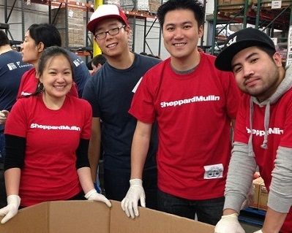
Awards
All organizations that participate in the competition will receive an Achievement Award. An Overall Award will be presented to the organization with the highest overall combined totals. A Highest Per Capita Award will be presented to the organization with the highest overall per capita contributions.

For more information, contact Christina Quezada at (323) 234-3030 ext. 163 or at cquezada@lafoodbank.org

