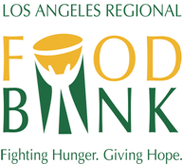**Child and Adult Care Food Program (CACFP)/**

**Summer Food Service Program (SFSP)**

**SITE RULES**

1. Meals are for children only. No one over age 18 will be served.
2. Meals must be eaten on site. Food cannot be taken from this site.
3. Meals will only be served between

**____________________ ____________:____________ to ­_____________:_____________**

**(Meal) (Start Time) (End Time)**

1. Children must behave in an orderly fashion.
2. Seconds may be served only after all children have been served a first meal.
3. This site will be closed if these rules are not followed.
4. Adults cannot eat at this site.

